Research & Implementation of Web Application Vulnerability Scanner
Among the most used systems in the current cybersecurity are web applications because they are publicly accessible. This assignment involved a study on the popular web application vulnerabilities and a Python based scanner that I used to automatically identify the security vulnerabilities in a live site set-up.
Research
I conducted a research on three significant types of web application vulnerabilities. To begin with, the absence of security headers: HTTP response headers such as Content-Security-Policy, X-Frame-Options, and Strict-Transport-Security are the key factors that can protect against such attacks as Clickjacking, XSS, and protocol downgrade attacks. Their inability is categorized as CWE-693 (Protection Mechanism Failure). Second, sensitive path disclosure - the credentials, source code, or database setup of an application can be disclosed to an attacker by files like .env, .git/config, and backup.zip kept publicly accessible, as cited in CWE-538. Third, Cross-site scripting (XSS) - When input supplied by the user is reflected in a web response without appropriate sanitization, attackers may inject malicious scripts to steal sessions or redirect users, and falls in the CWE-79 category, and is always in the OWASP top 10.
Implementation
I used built-in urllib and html libraries, which do not need any outside installations, to install a Python web application scanner. The tool makes three autonomous examinations towards a goal website. It first forwards an HTTP request and analyses the response headers, labeling any security header lacking with its risk. Second, it scans a list of ten frequently exposed sensitive routes and logs any which respond with HTTP 200 or 403. Third, it runs a standard XSS test payload into a URL parameter and verifies its presence in its unsanitized form in the response. All results are summarized in a well-organized report by the severity CRITICAL, HIGH, MEDIUM, or LOW and five tangible remedies such as Web Application Firewall implementation and restricting the path of the admins to internal IPs only.
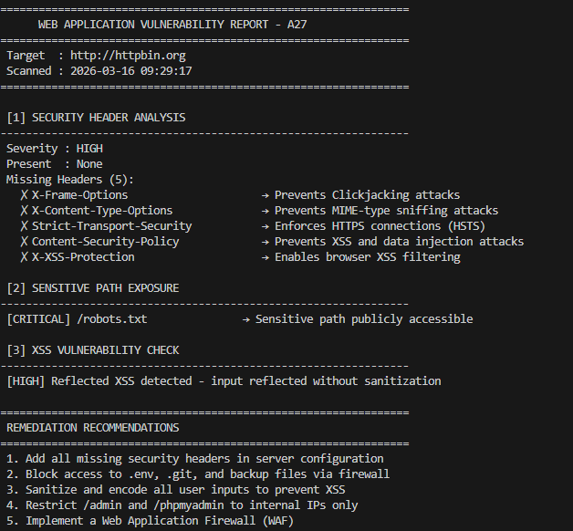
This implementation shows practical, hierarchical identification of the real-world vulnerabilities of the web.

